Final Practical Exam

Instructions

1. Create the repo:**practical-work-calculator_lastname-firstname**
2. Create the file **calculator.html** and the file **js/calculator.js**
3. Copy the below code
4. Do not modify the HTML or CSS
5. Don't use any libraries or frameworks

Functionality

When the page is opened, only the "Calculator" button should be visible

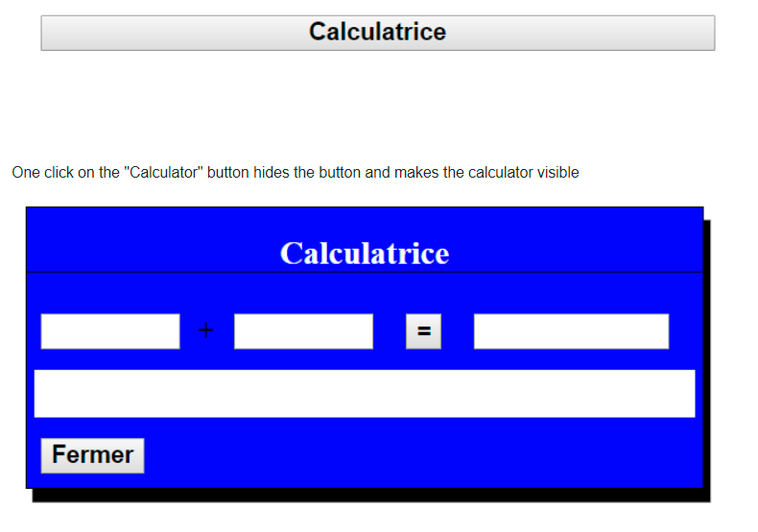

One click on the "=" button displays the results of the addition or the word "Error" if the result is not a numeric value.

When a value is entered:

1. A descriptive message will be displayed below when the cursor is placed in one of the input fields.
2. Field value1: "Enter the first numeric value"
3. Field value2: "Enter the second numeric value"
4. The message should disappear when clicking anywhere else.

After having entered each value, validation will occur when the field is left:

1. If the value is not numerical, the "invalid" class must be added to the input to indicate an error has occurred

One click on the "Close" below the calculator

1. Reinitialize all its values
2. Closes the calculator and makes the initial "Calculator" button visible again